**Hibernate Life Cycle:**

The Hibernate life cycle refers to the stages an entity (object) goes through during its interaction with Hibernate and the database. Each stage has its own behavior and characteristics, depending on whether the object is managed by the Hibernate session or not. Here's a breakdown:

**1. Transient State**

* When an object is created using the new keyword but not yet associated with any Hibernate Session, it is in the transient state.
* Key Characteristics:
  + It has no persistent representation in the database.
  + Changes to the object are not tracked by Hibernate.
  + It is not managed by Hibernate.
* **Example**:

Employee employee = new Employee();

employee.setName("John"); // Transient state

**2. Persistent State**

* An object enters the persistent state when it is associated with an open Hibernate Session.
* **Key Characteristics:**
  + It is managed by the Hibernate session.
  + Any changes made to the object are automatically synchronized with the database when the transaction is committed.
  + The object has a representation in both the database and the session's cache.
* **Example:**

session.save(employee); // Now the object is persistent

employee.setName("John Doe"); // Automatically synchronized with the database

**3. Detached State**

* When the Hibernate session is closed, or the object is explicitly evicted from the session, the object enters the detached state.
* **Key Characteristics:**
  + It is no longer managed by Hibernate.
  + Changes made to the object are not automatically synchronized with the database.
  + It still has an identifier that matches its database record.
* **Example:**

session.close(); // The object is now detached

employee.setName("New Name"); // Changes will not reflect in the database

**4. Removed State**

* When an object is marked for deletion (using session.delete()), it enters the removed state.
* **Key Characteristics:**
  + The object is scheduled for deletion in the database upon transaction commit.
  + It is still managed by the session until the transaction is committed or rolled back.
* **Example**:

session.delete(employee); // Marked for removal

**Transition Diagram Overview:**

* **Transient → Persistent**: Use session.save() or session.persist().
* **Persistent → Detached**: Use session.close(), session.evict(), or session expiration.
* **Detached → Persistent**: Use session.update(), session.merge(), or session.lock().
* **Persistent → Removed**: Use session.delete().

Understanding these states and transitions helps you manage your entities effectively and avoid common issues like LazyInitializationException or improper session handling. Let me know if you'd like a visual diagram or further examples!

**Hibernate Lifecycle Diagram (Description)**

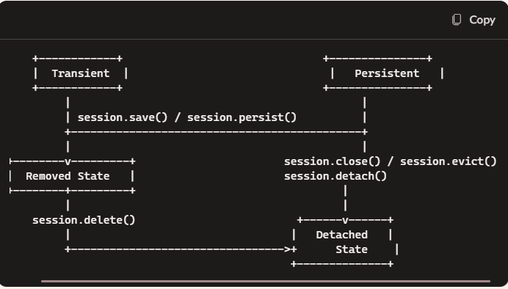

**Key Elements:**

* **Transient State**:
  + Object is created but not associated with Hibernate.
  + Moves to the **Persistent State** via session.save() or session.persist().
* **Persistent State**:
  + Object is managed by the Hibernate session.
  + Moves to the **Detached State** if the session is closed or the object is evicted.
* **Detached State**:
  + Object is no longer managed by Hibernate.
  + Can be reattached to the session using session.update(), session.merge().
* **Removed State**:
  + Object is marked for deletion via session.delete() and will be deleted upon transaction commit.

You can use this layout to draw a flowchart using tools like Lucid chart, draw.io, or even on paper. Let me know if you want further details or help in creating the diagram!

**What is Object Eviction?**

In Hibernate, **"evicted"** refers to the process of explicitly removing an object from the Hibernate Session. When an object is evicted, it transitions from the **persistent state** to the **detached state**.

This means the object is no longer managed by the Hibernate session, and any changes made to it will not be tracked or synchronized with the database unless it is explicitly reattached to the session.

**Why Use session.evict()?**

You might want to evict an object in scenarios where:

1. **Memory Management**: To free up memory by removing unnecessary objects from the Hibernate session.
2. **Avoid Automatic Updates**: If you don't want changes in an object to be automatically reflected in the database.
3. **Detached Logic**: To handle an object in a detached state for specific use cases, such as serializing the object or applying custom logic.

**Example of Evicting an Object:**

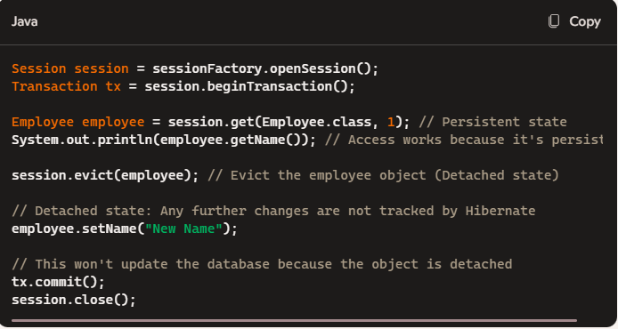

**Key Points to Note:**

* After calling session.evict(), the object is no longer associated with the session.
* Any changes made to the evicted object won't be saved to the database unless it's explicitly reattached using methods like session.update() or session.merge().

Eviction is a useful tool for controlling Hibernate's session behaviour, but it requires careful handling to avoid losing track of important changes to your objects. Let me know if you need further clarification!